**HTML Pages (Web App - make it portable for phone and web page)**

1. Start with **menu.html** - logo in pictures file. This style in css folder in template (separated)

Cantikkn from size

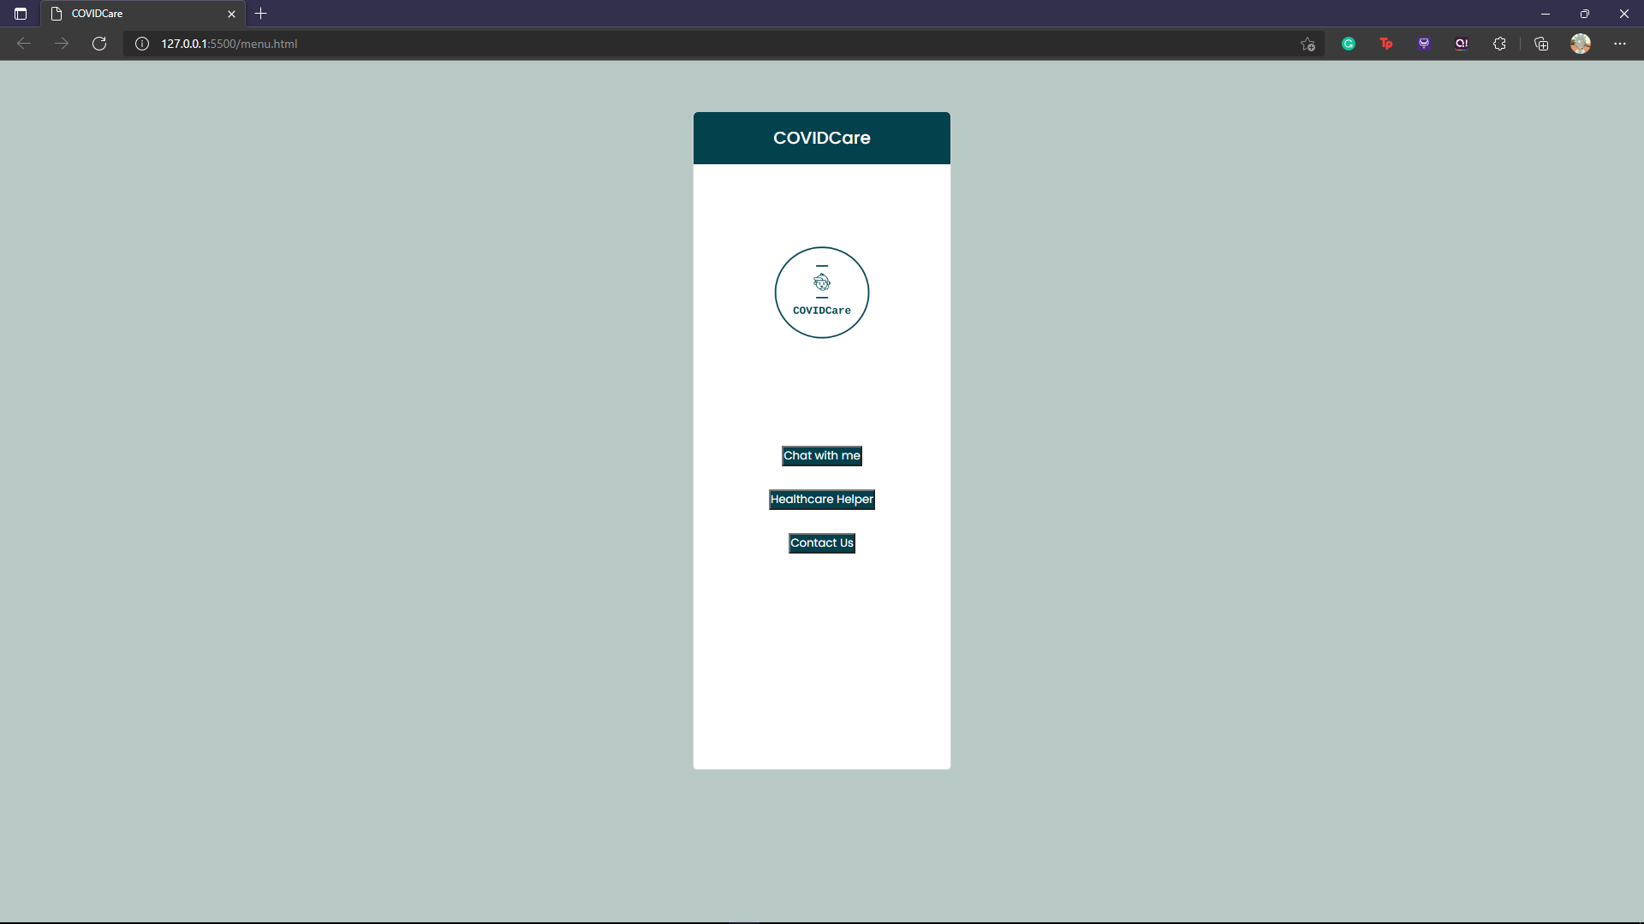

1. If click on “chat with me” it will go to page **index.html** (the chatbot interface)

Change it like this -> bole scroll. Chatbot logo can change to something cute/pretty

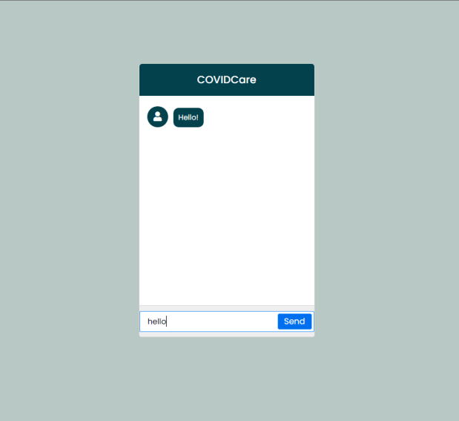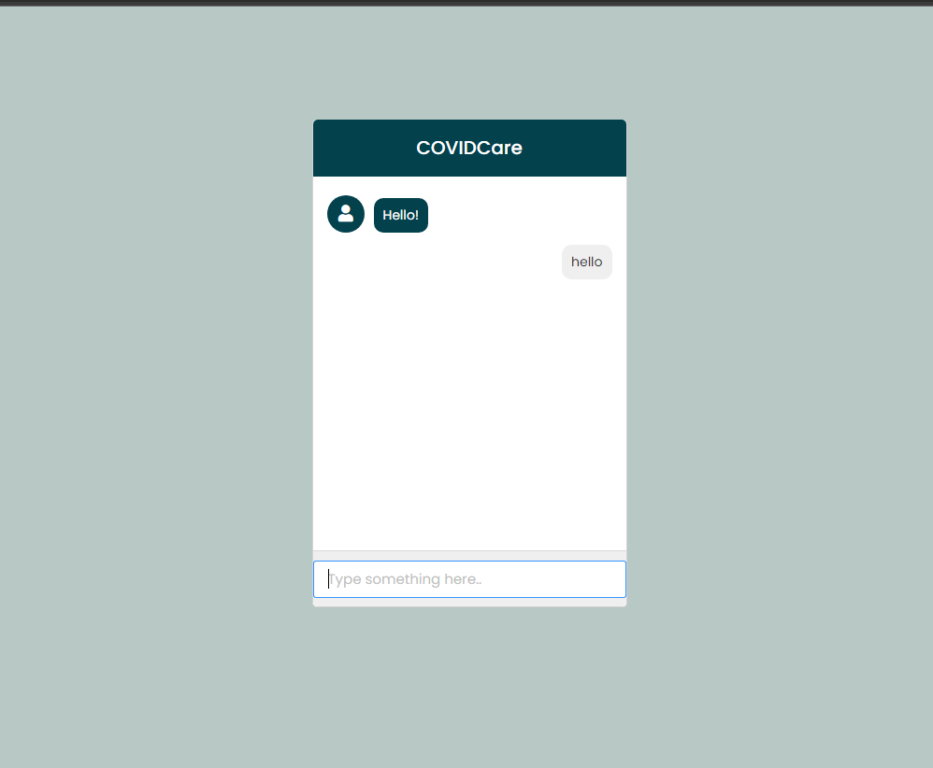

For now, **index.html** display ni

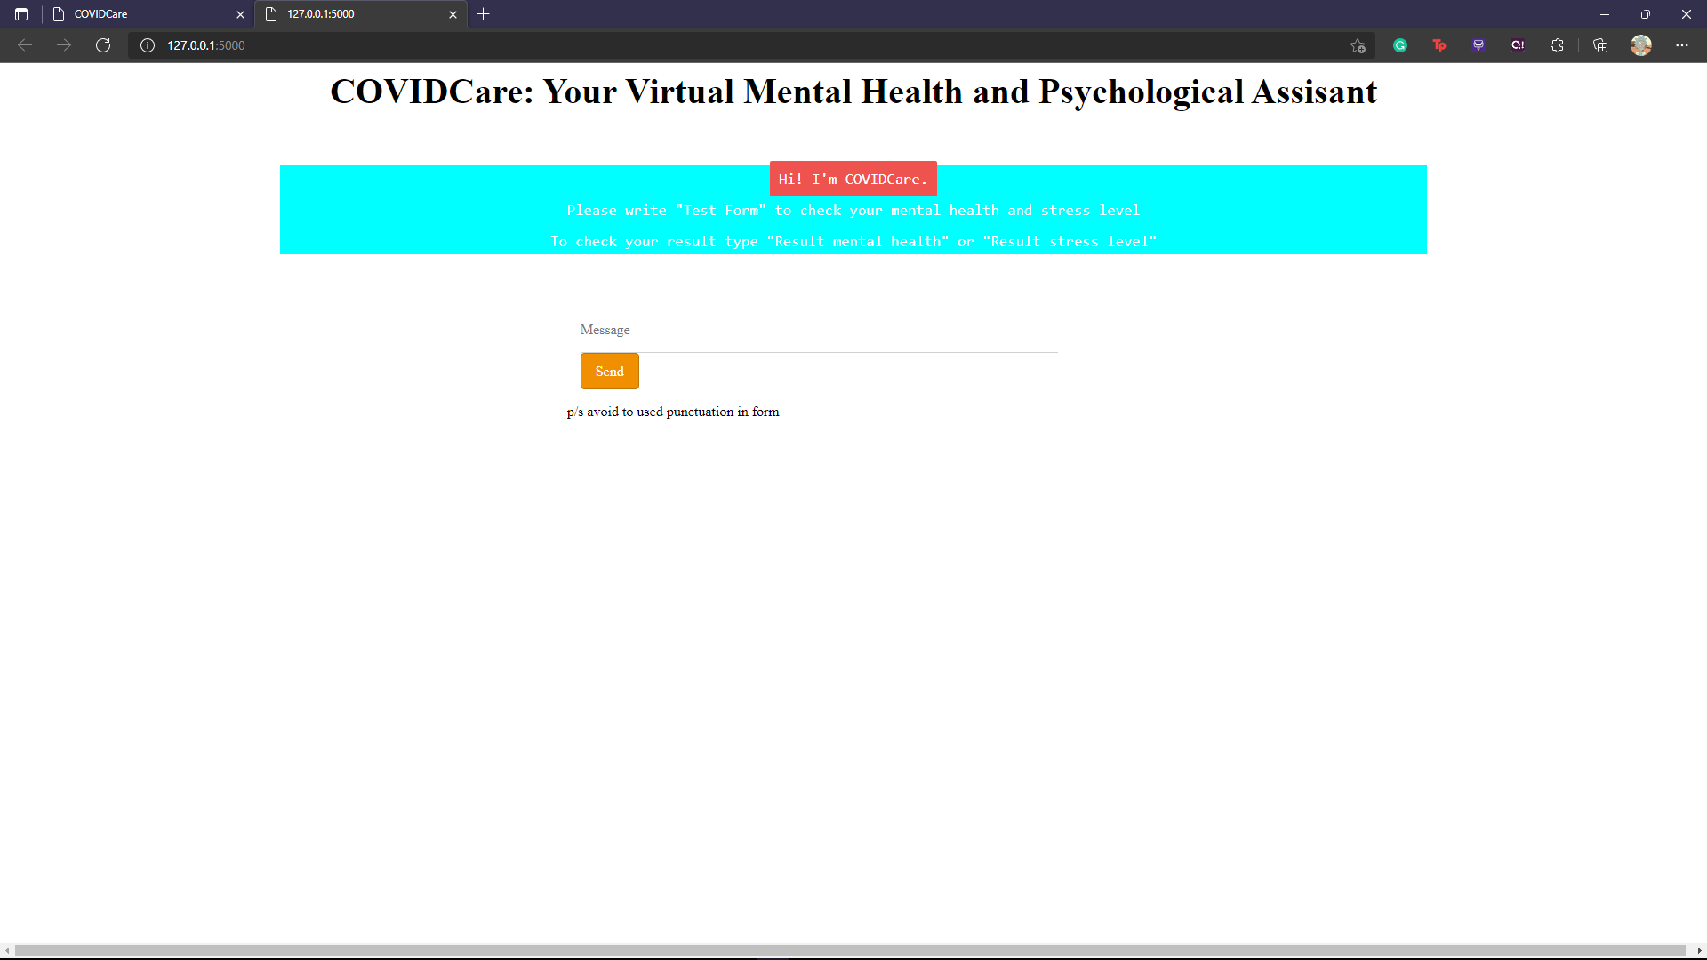

If input message “Test Form” -> watch chatbot.mp4 in template files (the flow of the chatbot)

That is the **layout.html** where the questions are stored. After submit supposedly will show table of the result (**sheet.html**) - pls cantikkan this page also.

So that’s for “chat with me” interfaces.

1. Then, if from **menu.html** we click on “healthcare helper” will open **healthcarehelper.html**

It has 3 function - Depress, Eating pattern, workload. Cantikkan. Since there’s uneven form.

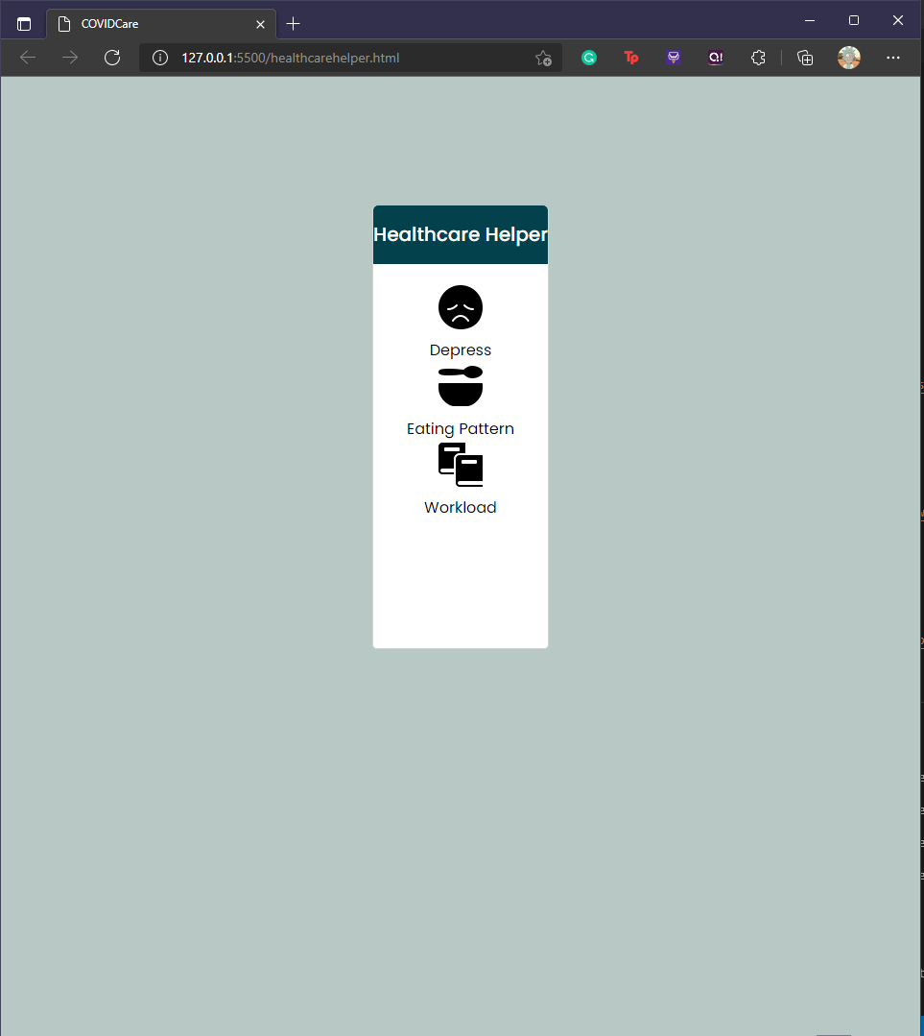

Depress will open **playlist.html** to play song

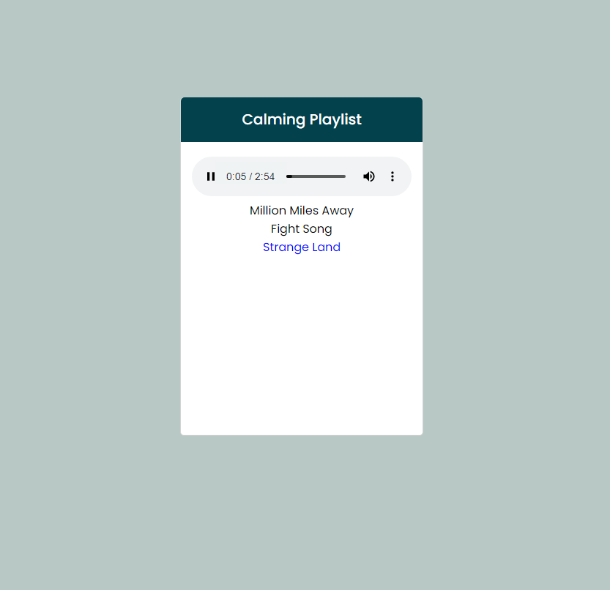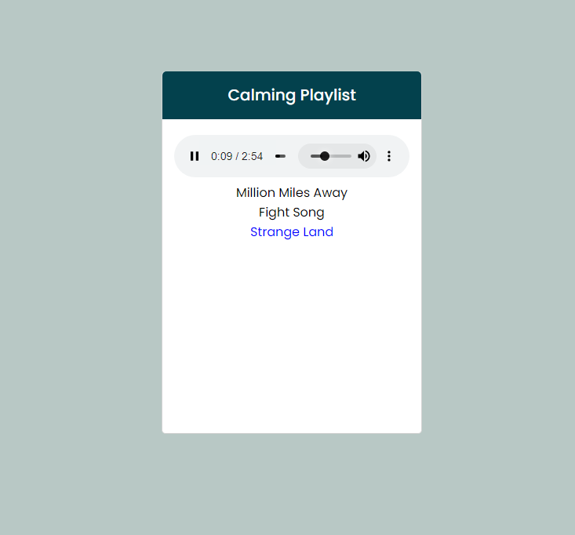

Eating pattern will open **healthyhabits.html** (supposedly display videos suggestion on healthy eating habits) pls insert

Workload will open **timemanagement.html** ( same with this one - display videos time management related) pls insert

Dua2 ni still empty

1. Lastly from **menu.html**, click “contact us” will open **contactpage.html** (pls edit)

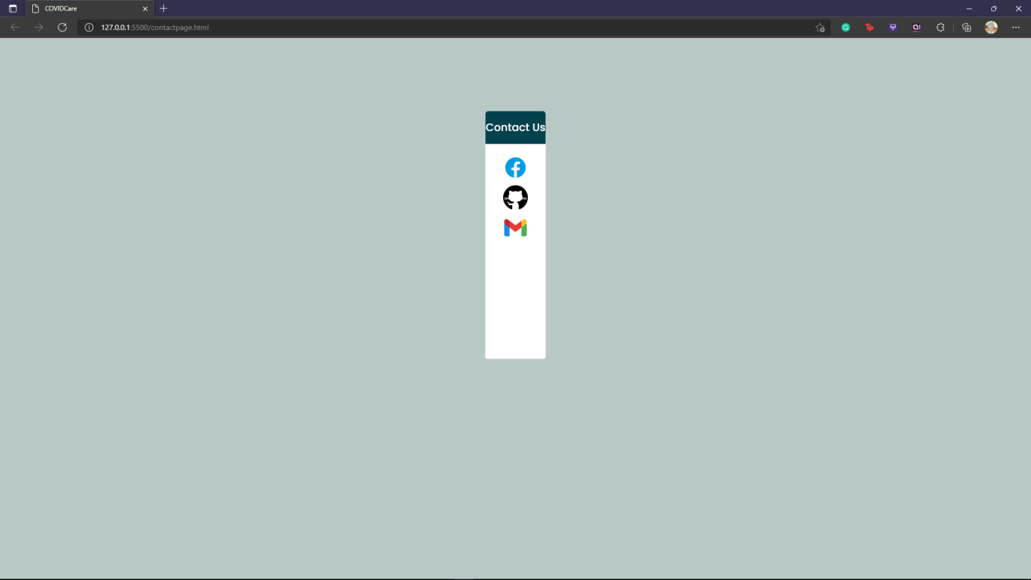

Basically this is the wireframe..

https://www.figma.com/file/iXTC5ePhNm2ifTpRkVvWW7/COVIDCare-Flow-Mental-Health-Helper?node-id=0%3A1

Thank you.

**Flask & Html**

1. Design part html & css
2. Code html in template folder
3. Css in static folder
4. Html link dgn flask python
5. HOW TO RUN FLASK (Only change path after run trainingchatbot.py)
6. Flask python will become main.py
7. Train manual utk dptkan chatbot.h5(chatbot chat yg kamu build hari tu), model.json(emotion and stress level detection)
8. Bila dh abis train semua copy path .h5, .json and .pkl yg dh train store sekali dgn main.py code

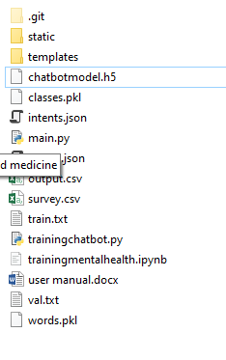

* 1. Run main.py nnti dlm terminal dia bg link domain (http://127.0.0.1:5000/) click to open web browser

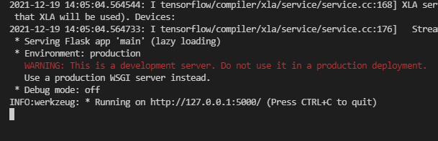

* 1. Run then can test
  2. Make sure update .h5, .json, pkl model
  3. Nnti test akan ada 3 command fixed. (“Test Form”, “Result Stress Level”, “Result mental health”)
  4. Test form utk open emotion question and test level questio. After submit supposedly will redirect to sheet.html (table to show the result)

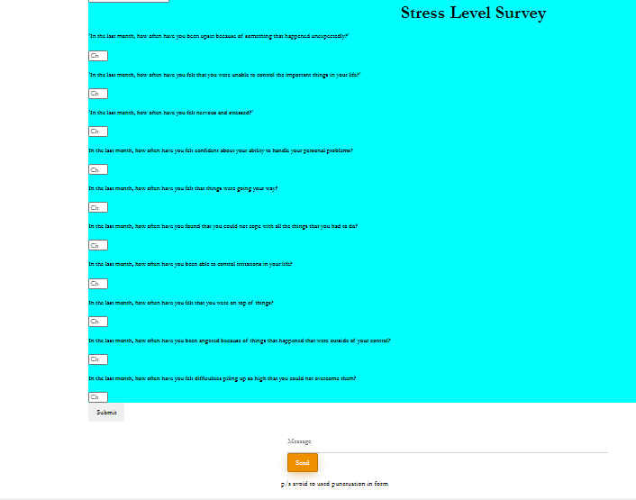

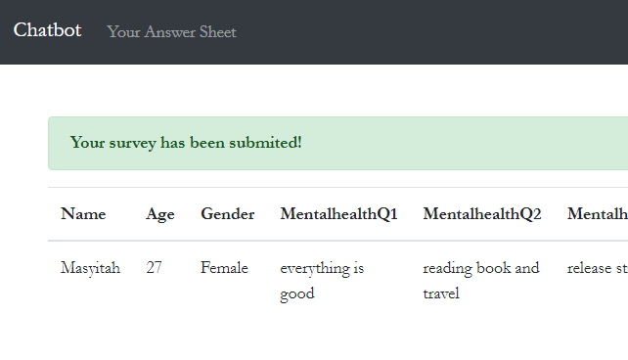

* 1. Click “Chatbot” to go back to chatbot page (index.html)
  2. Pastu “Result mental health” @ “Result stress level” tuk tgk result dr kita isi tu.